WPF Backup Application - User Guide

Introduction
This graphical application lets you manage backup jobs interactively via a graphical user interface (WPF). Users can navigate the menus by clicking on the buttons corresponding to the desired option.
Main window
Options :
Allows you to change options, opens the options window.
More :
Allows you to create backup jobs, opens the backup creation window.
Start selection :
Starts the selected backup jobs. To select backup jobs, click on the corresponding line or lines in the table.
Swap type :
Changes the backup type for the selected line(s).
Delete :
Deletes the backup job for the selected line(s).

Backup creation window
Name :
Allows you to name your backup job.
Source :
Allows you to enter the source path.
Destination :
Allows you to enter the destination path.
Type :
Allows you to choose between a ‘Differential’ or ‘Full’ backup.

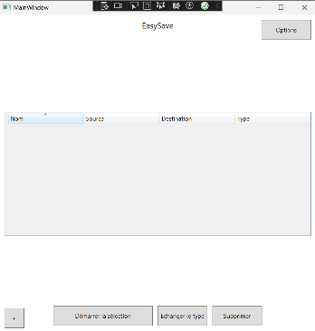
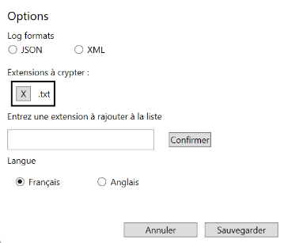
Options window
Log formats :
Allows you to choose the log format between JSON and XML.
Extensions to encrypt :
Allows you to enter the extension(s) to be encrypted. Press confirm to save your choices. You can delete extensions to be encrypted by clicking on the small cross next to the extension name.
Language :
Allows you to choose between French and English.
